**FROM CONFUSION TO A SINGLE NUMBER**

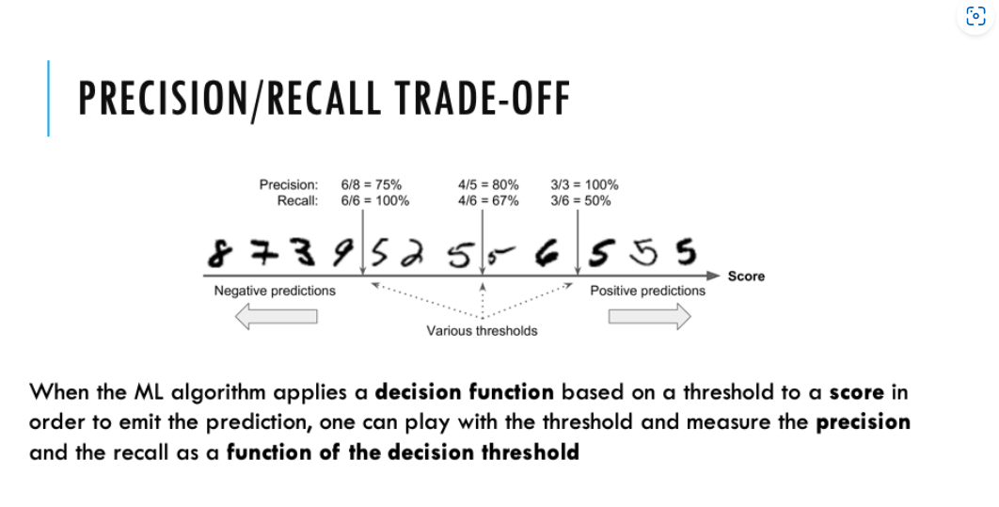

improve my precision: find the best threshold which allow me to get my goal precision and evaluate what is the goal evaluated to the threshold

train algorithm and split the dataset in train and test